UML Class Diagrams and configuration management

Class Diagrams
Class diagrams are used when developing an object-oriented system model to show the classes in a system and the associations between these classes.
- An object class can be thought of as a general definition of one kind of system object.
- An association is a link between classes that indicates that there is some relationship between these classes
- When you are developing models during the early stages of the software engineering process, objects represent something in the real world, such as a patient, a prescription, a doctor, etc.

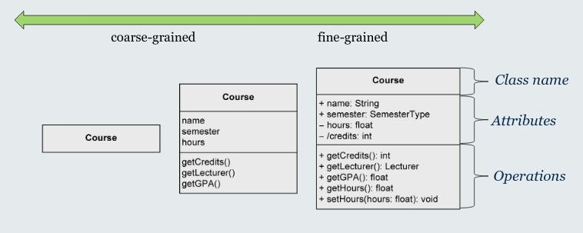
Creating a class diagram
- It is not possible to completely extract classes, attributes and associations from a natural language text automatically.
- Some guidelines:
  - Nouns often indicate classes
  - Adjectives often indicate attribute values
  - Verbs often indicate operations
e.g.:
The library management system stores users with their unique ID, name and address as well as books with their title, author and ISBN number. Ann Foster wants to use the library.
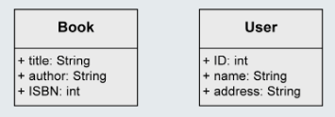

From objects to class
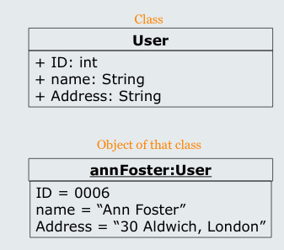
Individuals of a system often have identical characteristics and behaviour
A class is a construction plan for a set of similar objects of a system.
- Objects are instances of classes
Attributes: structural characteristics of a class
- Different value for each instance (=object)
Operations: behaviour of a class
- Identical for all objects of a class
- Not depicted in object diagram

Example – university information system
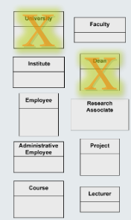
A university consists of multiple faculties which are composed of various institutes. Each faculty and each institute has a name. An address is known for each institute.
Each faculty is led by a dean, who is an employee of the university.
The total number of employees is known. Employees have an SSN, a name, and an email address. There is a distinction between research and administrative personnel.
Research associates are assigned to at least one institute. The field of study of each research associate is known. Furthermore, research associates can be involved in projects for a certain number of hours, and the name, starting date, and end date of the projects are known. Some research associates hold courses. Then they are called lecturers.
Courses have a unique number (ID), a name, and a weekly duration in hours.

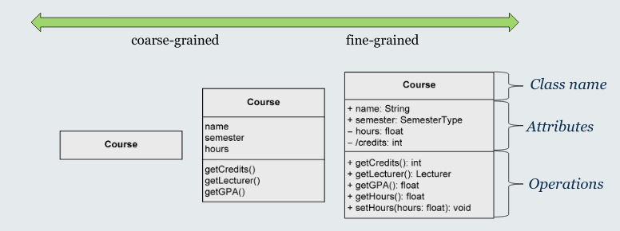

Attribute syntax
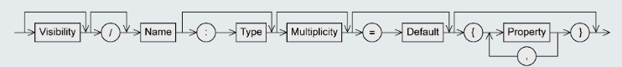

Visibility
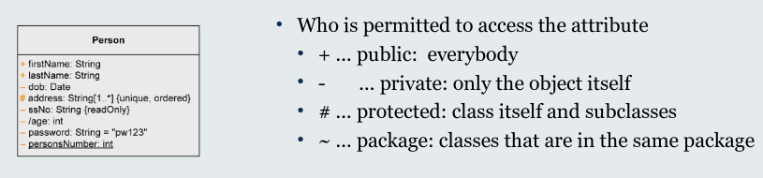

Derived attribute
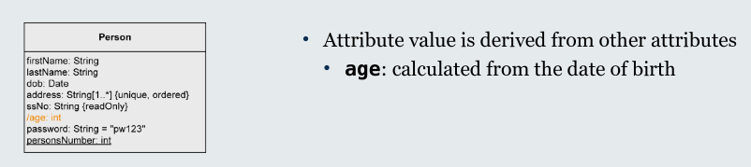

Name
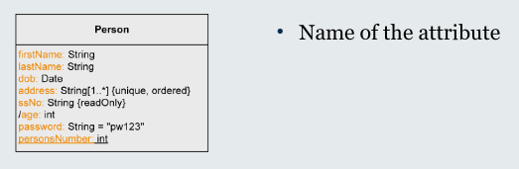

Type
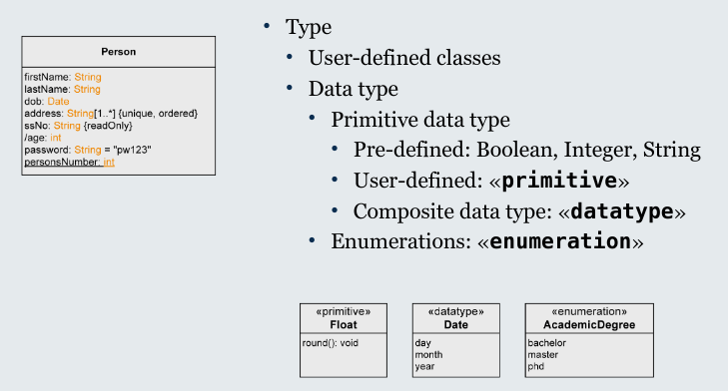

Multiplicity
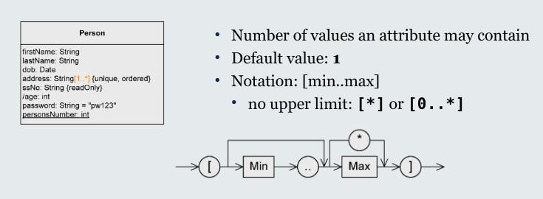

Default value
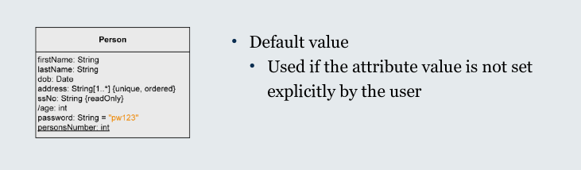

Properties
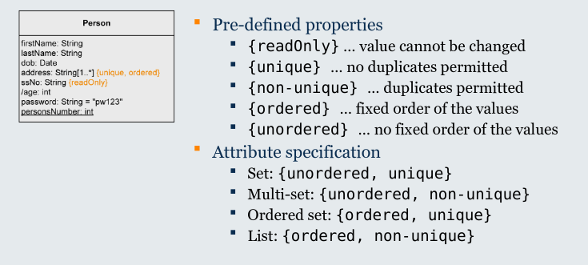

Example 2: Identifying the attributes
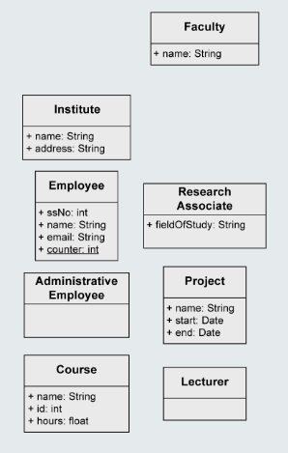
A university consists of multiple faculties which are composed of various institutes. Each faculty and each institute has a name. An address is known for each institute.
Each faculty is led by a dean, who is an employee of the university.
The total number of employees is known. Employees have an SSN, a name, and an email address. There is a distinction between research and administrative personnel.
Research associates are assigned to at least one institute. The field of study of each research associate is known. Furthermore, research associates can be involved in projects for a certain number of hours, and the name, starting date, and end date of the projects are known. Some research associates hold courses. Then they are called lecturers.
Courses have a unique number (ID), a name, and a weekly duration in hours.

Operation syntax

Parameters
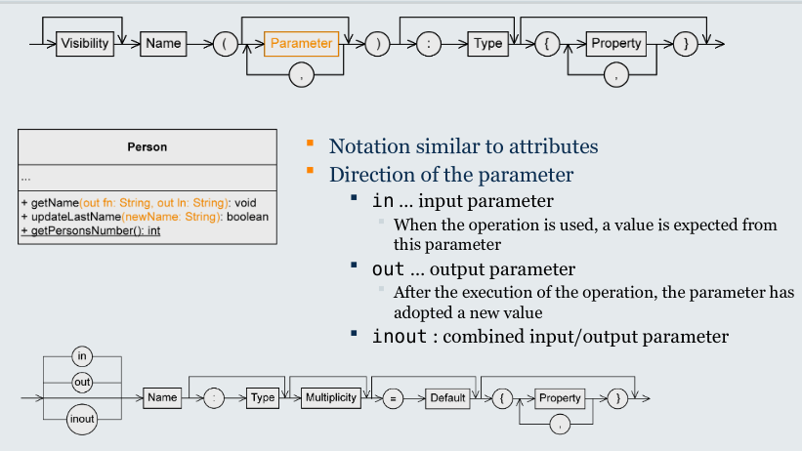

Type
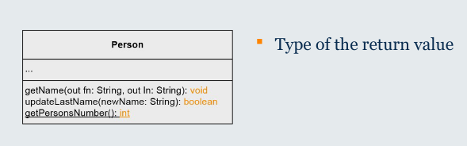

Class diagrams and relationships

Binary association
- Define relationships between instances (objects) of classes.
- There is an association between two classes if an instance of one class must know about the other in order to perform its work
- Role names and multiplicities at both ends
- In uni-directional associations, role name at start of arrow is optional
- Formalise requirements such as “Each professor may coach a set of students, and each set of students is coached by exactly one professor”
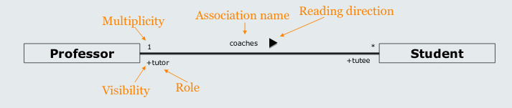

Multiplicity and role
- Multiplicity: Number of objects that may be associated with exactly one object of the opposite side
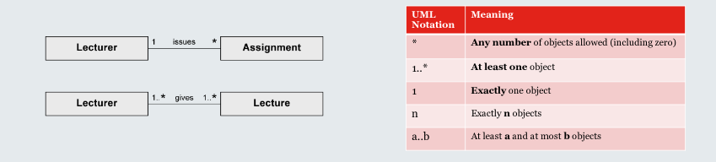
- Role: describes the way in which an object is involved in an association relationship
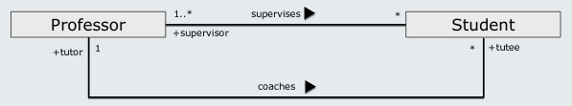

Unary association example
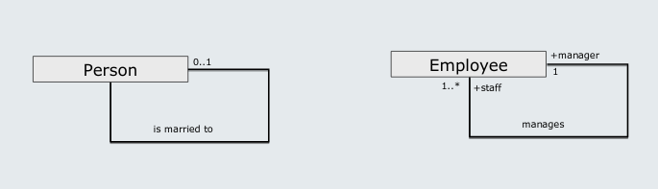

Association class
Assign attributes to the relationship between classes rather than to a class itself
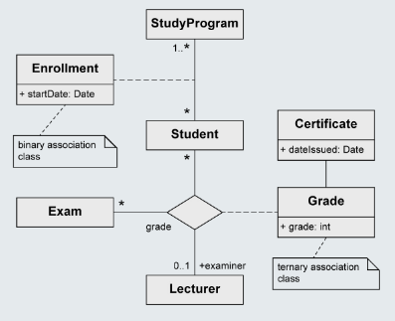
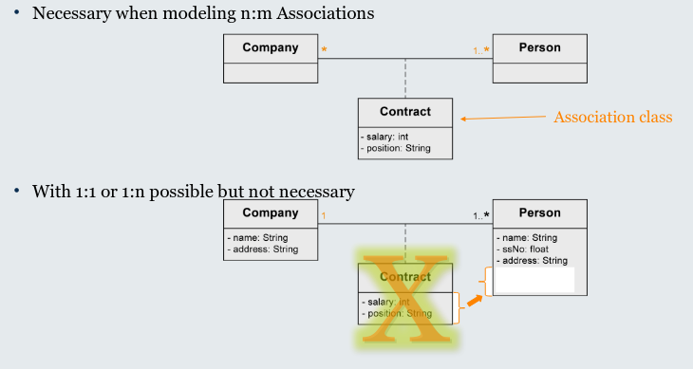

vs. regular class
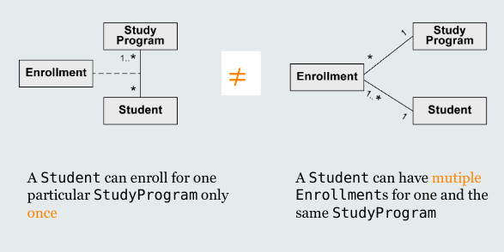

Aggregation
- A special form of association
- Used to express that a class is part of another class
- Properties of the aggregation association:
  - Transitive: if B is a part of A and C is a part of B, C is also a part of A.
  - Asymmetric: it is not possible for A to be a part of B and B to be a part of A simultaneously

Shared aggregation
- Expresses a weak belonging of the parts to a whole
  - = Parts also exist independently of the whole
- Multiplicity at the aggregating end may be >1
  - = One element can be a part of multiple other elements simultaneously
- Spans a directed acyclic graph
- Syntax: Hollow diamond at the aggregating end
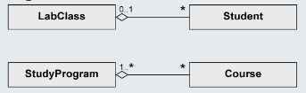
- Example:
  - Student is a part of LabClass
  - Course is a part of StudyProgram

Composition
- Existence dependency between the composite object and its parts
- One part can only be contained in at most one composite object at one specific point in time
  - Multiplicity at the aggregating end max. 1
  - The composite objects form a tree
- If the composite object is deleted, its parts are also deleted
- Syntax: Solid diamond at the aggregating end
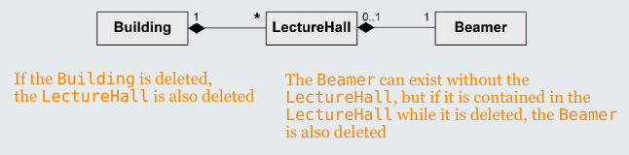
- Example:
  - Beamer is a part of LectureHall is a part of Building

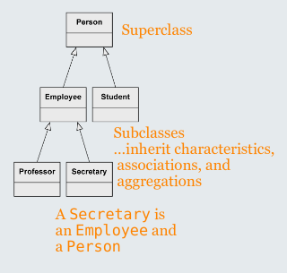
Generalization
- Characteristics (attributes and operations), associations and aggregations that are specified for a general class (superclass) are passed on to its subclasses.
- Every instance of a subclass is simultaneously an indirect instance of the superclass.
- Subclass inherits all characteristics, associations, and aggregations of the superclass except private ones.
- Generalizations are transitive.

Multiple Inheritance
UML allows multiple inheritance, such that a class may have multiple superclasses.
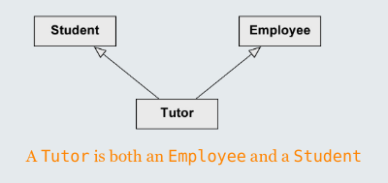
e.g.:

Complete class diagram
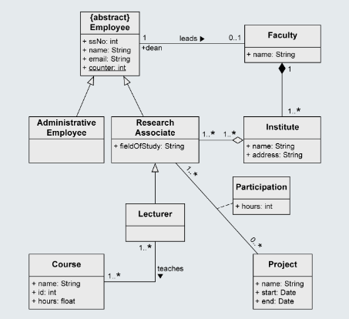

Consistency rules
- NO two attributes with same name
- NOT an attribute and a role with same name
- NO two associations from one class with same role names at their other ends – even if they end at different classes.

Configuration management
- Software systems are constantly changing during development and use
- Configuration management is concerned with the policies, processes and tools for managing changing software systems
- You need CM because it is easy to lose track of what changes and component versions have been incorporated into each system version
- CM is essential for team projects to control changes made by different developers

CM activities
- Version management
  - Keeping track of multiple versions of system components and ensuring that changes made to components by different developers do not interfere with each other.
- System building
  - The process of assembling program components, data and libraries, then compiling these to create an executable system
- Change management
  - Keeping track of requests for changes to the software from customers and developers, working out the costs and impact of changes and deciding the changes should be implemented
- Release management
  - Preparing software for external release and keeping track of the system versions that have been released for customer use.
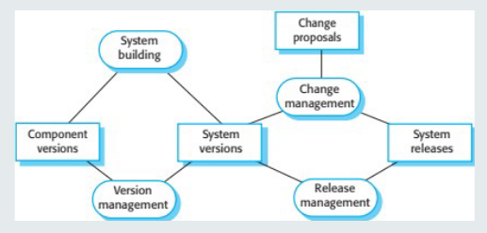

Agile development and cm
Agile development, where components and systems are changed several tiles per day, is impossible without using CM tools.
- The definitive versions of components are held in a shared project repository and developers copy these into their own workspace.
- They make changes to the code and then use system building tools to create a new system on their own computer for testing. Once they are happy with the changes made, they return the modified components to the project repository.

Development phases
- A development phase is where the development team that’s responsible for managing the software configuration add new functionality to the software.
- A system testing phase is where a version of the system is released internally for testing.
  - No new system functionality is added. Changes made are bug fixes, performance improvements and security vulnerability repairs.
- A release phase is where the software is released to customers for use.
  - New versions of the release system are developed to repair bugs and vulnerabilities and to include new features.

Multi-version systems
For large systems, there is never just one ‘working’ version of a system. There are several versions of the system at different stages of development.
There may be several teams involved in the development of different system versions.
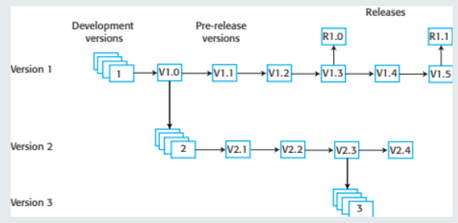

Terminology
